The World's Most Dangerous Fish
*NOTE: ALL IMAGES ARE FOR REFERENCE / EXPLANATION PURPOSE ONLY AND THESE WILL BE RECREATED IN THE ACTUAL ANIMATION*
Disclaimer: GLOBAL - Please maintain consistency in look for the characters in the SB based on the sketch in the pdf. Images in SB are only for referential purpose. The sketch artist/animator can adapt it to the required style of presentation – vector, clipart or cartoon
Animate each image in the required manner.
Show the characters based on the following images. Other images in SB are only for reference of body language and expression.
Frame | Description | Audio
1 | Show a teacher standing in front of a board with ‘Dangerous Animals’ written on it. Show her talking to the students. | Kids, all of us know that some animals are friendly and some are dangerous.  Let’s begin today’s class with a quick question. Can you name a few dangerous animals?
2 | Show the students raising hands one by one, and speaking out the names of the animals given in the column alongside.  Show the images of the animals (with their name written below) mentioned by the students for better reference. | - tiger  - leopard  - wolf  - lion  - hyena
3 | Show the teacher talking to the students. | Great! Each one of you named a dangerous land animal. Does that mean there aren’t any dangerous animals in the water? Well, no. There are some mysterious and dangerous aquatic creatures as well. Let us learn about some of them.
4 | Show the teacher talking on the left-side of the screen. Above her head, write the number ‘1’. Show a great white shark swimming in the water.  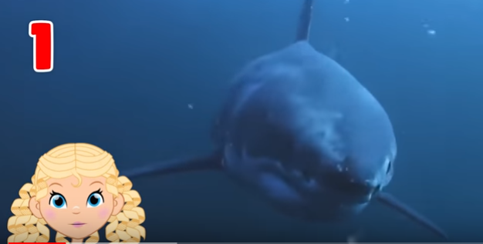  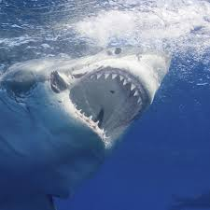  To add to the effect, show the students leaving a gasp or other signs of amazement after each sea creature is shown. | The great white shark is 15 feet in length and weighs about 2000 kgs. It has 300 sharp teeth. It is the largest predatory fish.
5 | Show the teacher talking on the left-side of the screen. Above her head, write the number ‘2’. Show an electric ray swimming in the water.  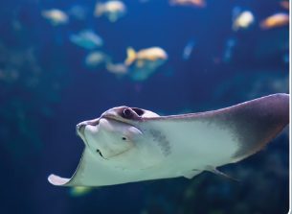 | The electric ray stuns its prey and  protects itself from its predators by producing electric current that ranges from 50 to 200 volts. It is generally harmless but becomes aggressive when touched or stepped upon.
6 | Show the teacher talking on the left-side of the screen. Above her head, write the number ‘3’. Show a box jellyfish swimming in the water. 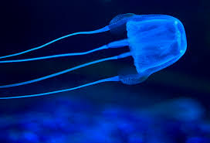 | The box jellyfish has a cube-shaped body with long tentacles hanging from four corners. Its stings contain toxins that instantly kill its prey.
7 | Show the teacher talking on the left-side of the screen. Above her head, write the number ‘4’. Show a blowfish swimming in the water.  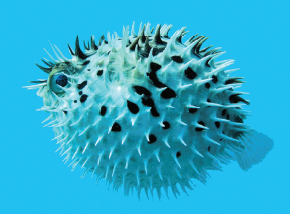 | As the name suggests the blowfish blows itself up several times its normal size to escape its predators. Its poison can kill 30 human adults.  Its meat is a Japanese delicacy called fugu, prepared only by expert chefs. The blowfish is also called the pufferfish.
8 | Show the teacher talking on the left-side of the screen. Above her head, write the number ‘5’. Show a stonefish swimming in the water.  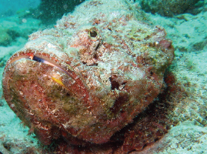 | A brownish-coloured fish, the stonefish looks like a stone on the ocean floor because of its ability to quickly blend in with its surroundings. It uses it venom to catch its prey and to stay away from predators. It can even kill an adult human in less than an hour.
9 | Show the teacher in the middle of the screen. She is talking. | Now, you will see the pictures of the fishes you learnt about. Guess their names. The hints you hear will help you.
10 | Show picture of electric ray. | I produce electric current.
11 | Show picture of stonefish. | It looks like a stone on the ocean floor.
12 | Show picture of box jellyfish. | It has a cube-shaped body.
13 | Show picture of blowfish. | My poison can kill 30 human adults.
14 | Show picture of great white shark. | I have 300 sharp teeth.

