**Admin page:**

**URL -** [**http://lyonsdemoz.net/cs/admin**](http://lyonsdemoz.net/cs/admin)

[**Username -**](http://lyonsdemoz.net/cs/admin) **admin@colourspace.com**

**Password - colourspace@321**

**Client page -** You can create your own login and password under each of the Client pages

**URL -** [**http://lyonsdemoz.net/cs/clients**](http://lyonsdemoz.net/cs/clients)

[**Name: Client Test - 2 April**](http://lyonsdemoz.net/cs/clients)

**Username - scott.ko+2@gmail.com**

**Password - password**

**Artist page:  
URL -** [**http://lyonsdemoz.net/cs/artist**](http://lyonsdemoz.net/cs/artist)

* [**Name: Scott Ko Test 2 April**](http://lyonsdemoz.net/cs/artist)
* **Username - scott.ko+1@gmail.com**
* **Password - password**

**Artist sign-up page:**

URL - <http://lyonsdemoz.net/cs/home/registration>

**1) Artist uploads artwork**

# **1.1) Artist apply to join the network**

1. Artist sign up form
   * Inside the form fields, the light grey prompt text fields are not consistent. Can we please change the following light grey prompt text boxes (use the text below, in other words):
     1. First Name
     2. Last Name (instead of last_name)
     3. Suburb
     4. Your website
     5. Twitter URL
     6. Facebook URL
     7. Instagram URL
     8. Your Portfolio *(in the Choose File field where it says ‘No file chosen’)*

*Changes Done Please check and confirm*

1. Can we include a checkbox that integrates with Mailchimp so that their email addresses can be linked to our Mailchimp database? Done, Mailchimp API has been integrated. We have used the same MailChimp account which you shared for CS - Front site. Please confirm me the list that needs to be linked, currently we created a new list and have mapped it.
   * 1. The Artist database please
2. Can we have the ability to update the copy for T&Cs ourselves please. *Changes Done. Now we can change artist T&C content from backend content managment page where content key is Artist_reg_TandC*
3. For the newsletter subscription field below, please make sure the font is the same as the rest of the website.  *I just checked and font and fornt size of the content same as the website font and font size*
4. Thank You page:
   * Please change this to ‘Thank you’ and not ‘Thanku’ *Changes Done Please check and confirm*

**1.3) Artist access their account (**[**scott.ko+3@gmail.com**](mailto:scott.ko+1@gmail.com) **// password)**

Password Reset page

1. When the reset email is sent, please change the text description to: Success! Please check your email for the link to change your password.  *Text changed with above text*
2. Then add a carriage return below that sentence and Forget Password

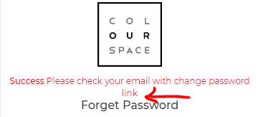 *Changes Done please check and confirm*

3. Let’s also add somewhere below the buttons: “Still having issues? Drop us an email at: [info@cs.gallery](mailto:info@cs.gallery)” *Changes Done please check and confirm*

Dashboard

1. No problems. What other notifications are you planning on displaying? Ideally, I would like to see the error messages be linked to the actual artworks themselves. For example, if ‘Missing artwork information’, I would like to be taken to the specific artwork in question In the “artist dashboard”, we are already showing three types of notifications namely - artwork missing information, artist bank details missing, artist profile details missing like the three questions, etc.
   1. Please confirm what all notifications you plan to include on the artist dashboard.
   2. Regarding linking the error message to actual atwork - Actually as you know we do not have any detail page (single page) of an artwork, rather artwork details are shown in a pop-up. So currently if we click on any missing information link on the dashboard then we are taking the user to the listing page.
   3. Please suggest.
   4. SK: Ok, I understand the pop up issue. No problems. In that case, can we at least have just the name of the artwork be displayed? In other words:
      1. “Missing artwork information” = “Missing information for artwork: <name>”
      2. “Artist bank detail missing” = “You’ve accrued royalties. Please update your BSB and Account details so we can process your royalties.”
      3. Artist profile details = “We’re missing information on your artist bio: <link>”. ← The link simply takes them to their Artist Bio page *Point 1,2,3 Changes Done please check and confirm.*
2. BUG: When all individual artworks have been correctly edited, there is still an alert o the Dashboard that says missing artwork information. *Issue fixed now please check and confirm*

Account Details

1. ALL APPROVED

Artist Bio

1. With the Your Artist Statement field, we will eventually need a word limit. This is what will be displayed on the Artist page, so we need it to fit properly. Let’s come back to this when we have the public front end connected and live. *For temporary i add the functionality for word limit 250 words the limit of words will increased or decreased depending on front end design*
2. Under ColourSpace questions, we don’t need this bit but please change the descriptive text red. *Query*



1. Under Involvement with ColourSpace, please add the following copy “We don’t just display art - we love collaborating with artists to help more people engage with art. Please indicate below which activities you would be interested in working with ColourSpace on.” Done
   1. Please don’t put ‘Please indicate below…’ on to a new line. Have it on the same line as ‘We don’t just…’ *Changs done please check and confirm*
2. We need a text field for the Involvement With ColourSpace part of the Artist Bio, so they can type in what else they want to do. Are you referring to adding a “textbox” in the “Involvement with CS” section on the artist edit screen. And this textbox will be shown only when the user selects “Others” option among the 6 checkboxes. Please confirm.
   1. Let’s just have a text box visible below the checkboxes by default. The text box will have the title: “Please elaborate where needed.” *Changes Done please check and confirm*
3. If the user has not finished updating the Artist Bio section, they are unable to access ‘Artworks shared with ColourSpace’, ‘Photos of your art on display’, or ‘Your royalties’ pages. This isn’t so much a bug but it’s not intuitive. Is it possible instead that those three menu items are not displayed unless the user completes their Artist Bio? Otherwise, please have the error as a pop up message instead.  *Changes Done now if artist has not finished updating of bio. Sidebar hide the other options.*

Artworks shared with ColourSpace page

1. Artworks shared with ColourSpace
   1. When uploading an image that’s too small, the error message disappears too quickly. See this video screenshot: <http://recordit.co/YV7Lpw07Mn>. Can we make this either a pop up message or have the error message on screen longer?  *Changes Done error message set longer*
   2. For the ‘Artwork details missing’ flag, please remove the . at the end of the mouse sentence. *Changes Done . Sign removed*
   3. For the Submitted for review flag, the spelling is wrong. Please change to: Submitted for review Changes *Done spelling corrected*

Edit individual artwork

1. With the Inches / CM radio button, are you able to input any algorithm that the dimensions automatically change when they click between the two? So if they enter 30in, then we click to cm, it converts the size to cm? 1 inch = 2.54cm *Functionality added whenever we click on cm or inc radio button input values will changes.*
2. Rename: “Is this piece a limited edition…” to: “Is this piece:” and then rename the radio button with Yes = Print, No = Original artwork (default Original artwork) Done
   1. Please rename label to: Is this piece: *← No question mark Changes Done Please chcek and confirm*
3. Add new radio above placed above the Price field. The text description is: “Is this piece framed / ready to hang?” with a Yes / No radio (default Yes) Done
   1. Please remove the space between ‘hang’ and the ?  *Changes Done Please chcek and confirm*
4. Rename the Price field to: “Price (please note ColourSpace charges 20% commission. Please include this in your price)” Done
   1. Please align field so the currency is display level with the price field  *Changes Done Please chcek and confirm*

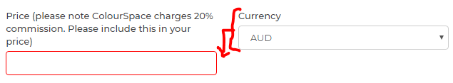

1. With Artwork description, can we please set a maximum word count of 100 Done
   1. Rather than a pop up box that appears after the user hits ‘Update Artwork’ is it possible to limit it within the text box? Eg, a countdown character count and then a hard limit within the text box? *Changes Done please check and confirm*
2. When artist enters price of artwork, if they enters a price below $250 can we please have a pop up message with an OK box that says:
   1. Please note, artworks under the value of $250 do not accrue royalties. Please see our FAQ for more information.  *Changes Done please check and confirm*

On uploaded of artworks

1. When Artist uploads an email and they are sent an email, can we remove the S. No column?  *Changes Done please check and confirm*

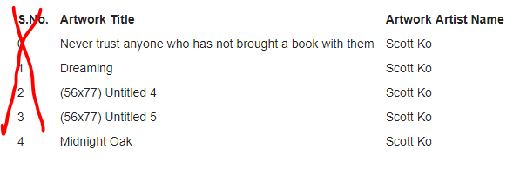

**1.2) ADMIN signs in to approve artist**

1. Admin signs in to approve artist *Artist Status Changed Please check and confirm*

**2) Admin manages portfolio**

**2.1) ADMIN signs in to review notifications**

1. Dashboard:
   1. I like that there is a notification for ‘Artist upload first time artworks’. What is the logic for this? As per your earlier request we simply display this notification when the artist uploads an artwork for the first time. When is this cleared? Logically, this should be cleared when all artworks listed against that artist has a status of Approved. Currently this notification is cleared as soon as the admin view that artwork irrespective of the fact whether it is approved or rejected, let me know if this needs to be changed. If the status is ‘Submitted for review’, then there should be a notification against that artist in the dashboard. See 2.2.2 below.
      1. This is the logic please:
         1. Let’s rename the ‘Artist upload first time artworks’ to ‘Artworks submitted for review’ *Text Changed Please check and confirm*
         2. All artworks Any artwork with a status of ‘Submitted for review’ is displayed in the Dashboard, whether by artist or by the individual artwork itself (whatever is feasible). This means the artwork needs to have ANY other status to not show up in this dashboard (whether ‘Approved’ or ‘Rejected’ or whatever)
   2. Let’s remove the ‘Artist list pending for removal’ from the dashboard *List remove please check and confirm*

**2.2) ADMIN reviews the artwork uploaded by artist**

Artist Database > Artwork page for an individual artist (scott.ko+3@gmail.com)

1. When I update the tag for a new, approved artwork, I’m getting the following bug where the ‘Return to artist’ flag appears: <http://recordit.co/o8CK152i52> *Bug Fixed please check and confirm*
   1. On further testing, it appears the flag appears specifically when I edit each individual artwork, and then click the ‘Update artwork’ button. It does NOT seem to be an issue if I bulk edit and apply a tag to several artworks at a time.
2. Once an artwork is approved, an email is sent to the Artist for each artwork that is approved. Is there a way to batch this together? For example, instead of an email for every single artwork, is it possible to simply send a single email: “Your artworks have been approved. Please login to your account to review the status of your artworks.” And that’s it? Done, Scheduled job has been set that will run after every 30 minutes and will be sending the consolidated status.
   1. Please remove S.No column from the email list. *Removed from the email Please check and confirm*

Artist Database > Artwork page > Edit Artwork for an individual artwork

1. ALL APPROVED

**2.3) Artist re-accesses their account (**[**scott.ko+1@gmail.com**](mailto:scott.ko+1@gmail.com) **// password) to check the status of their artwork**

Artworks shared with ColourSpace

1. For every artwork that has an **Under Review** status of ‘Approved’, let’s introduce a little green tick flag on the image that has a mouse hover of: “Approved” Done
   1. Can we please make the green arrow on a clear background, not a dark grey square? It’s hard to see.  *Changes Done background removed*

**2.4) ADMIN manages the art portfolio**

Artworks > Portfolio

1. Bug: The Filter button seems to be broken. *It wil be done later*
2. The Selection of artwork function still seems to be broken. This is the scenario that I’d like to play out:
   1. I apply a filter whereby Tag = Large, then I select 3 artworks
   2. I then apply a filter where Tag = Medium, then I select another 3 artworks
   3. In total, I should be able to see 6 selected artworks
   4. Is that possible?
   5. Have a [look at this video](http://recordit.co/aSh0EIOhfz) that shows this functionality in SmartImage
   6. Any response to this functionality? *It wil be done later*
3. When an Artist is deleted and they now have a status of: “Artist no longer with ColourSpace” can we please introduce this as a visual flag as well. Done
   1. Can we introduce the ability to filter by this status? For example, how do we see all artworks that have this status? Done Not yet tested due to Filter Bug.
4. Can we please add the following functionality to Bulk Edit:
   1. Date Collected / Return Date Done ← Tested. The ability to bulk edit the field works, but when I check the individual artwork, the dates didn’t actually apply. When I eventually applied a different field (Managed by ColourSpace below), one of the artworks had ended up having a date that defaulted to 31-12-1969.  *I just checked all is working fine. Please check again and confirm if there is still an issue.*
   2. Can we add the following filter options:
   3. Whether an artwork is a Print / Original Artwork (this is updated from the radio button above) Done Not yet tested due to Filter Bug.
   4. Ready to hang radio button Done Not yet tested due to Filter Bug.
5. BUG: The Select Artist filter doesn’t seem to work This one seems to be working fine, request you to please share a screenshot with me so we could reproduce the error. Not yet tested due to Filter Bug.
6. BUG: The Select Collection drop down has a list of collections that don’t exist Done Not yet tested due to Filter Bug.

**3) Admin compiles curation / collection**

**3.1) The ADMIN creates a new client in the CMS (**[**scott.ko+5@gmail.com**](mailto:scott.ko+5@gmail.com) **// password)**

1. ALL APPROVED

**3.2) The ADMIN creates a collection from the Artworks Portfolio page and assigns to a Client (Inspire9 > New Client Rotation 1)**

1. ALL APPROVED

**3.3) The ADMIN creates a Client Collection from the Client Page**

1. ALL APPROVED

**3.4) The ADMIN duplicates a Collection**

1. ALL APPROVED

**3.5) The ADMIN edits the metadata of a Collection**

1. ALL APPROVED

**3.6) The ADMIN edits artwork in a Collection**

1. When adding artworks to a Client Collection, it appears that every artwork has the flag that it is in a proposed collection. When hovered over, it shows ‘0’.  *Issue fixed please check and confirm*

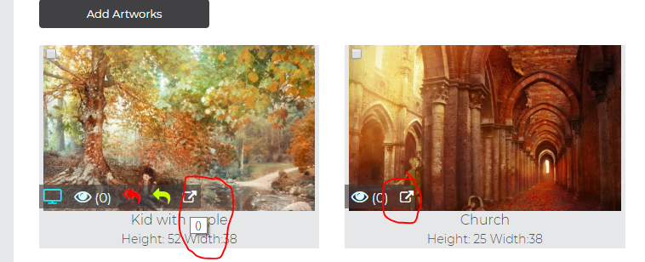

1. I added images to **Test Collection for New Test Client** (proposed collection). Then I added the same images to **Test Collection for New Test Client 2** (proposed collection). Now the images appear in both collections. Furthermore, selecting artworks has created a strange bug: <http://recordit.co/owUiQCW437>. This is another bug: <http://recordit.co/wNG4aavrfv> *Issue fixed please check and confirm.*
2. Sections: I need to keep testing this but I *think* this is on track.

**3.7) The ADMIN changes the status of a Client Collection (New Test Client)**

1. If I go to Clients > New Test Client > Rotations: I can now edit artworks in the collections (great). Is it possible to edit the metadata of the collection here? eg, change the status from Proposed to Approve.  *Yes we can change meta data of the collection please click on collection title a popup will open to update meta data of collection*

**3.8) The ADMIN deletes a Collection**

1. ALL APPROVED

**3.9) ADMIN can create a custom Public Collection that can be saved and shared**

Collections > Add new collection

1. Also - the ability to share a Public Collection means I should be able to eventually generate an HTML link that allows general users to find the Public Collection. Is this functionality currently included? It will be done along with the front website implementation. As the public collections will be accessible directly by general audience so doesn’t require login. NOTE: Scott will test later.

**4) Client reviews Client Collections**

So now, the new client has the chance to see what we’ve curated for them, and to leave their feedback and approvals. Login: [scott.ko+2@gmail.com](mailto:scott.ko+2@gmail.com) // password

**4.1) Client logs into their portal to review proposed collection**

Client Login page

1. Can we please adjust the banner so it scales to fit (see below) Done
   1. Scaling not quite fixed. Also, some strange visual bugs with artworks. When I go into a collection, and click on an artwork that’s irregularly size (this one is a portrait) the pop up of the image is enormous. See this example: <http://recordit.co/TcWbhy5GO7> *Issue fixed please check and confirm*
2. BUG: The Start Date and End Date do not seem to be connected to the dates of the Active Collection Done
   1. Still not connected. *Issue fixed now if there is no active collection then start date and end date will show 00-00-0000. Please check and confirm*

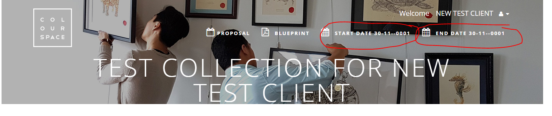

New: With the size - it looks like it’s picking up from both the original dimensions and the ‘additional comments for dimensions’ field filled in by the artist. Please do not include. We only want the original dimensions field (the first half). *Changes Done please check and confirm*

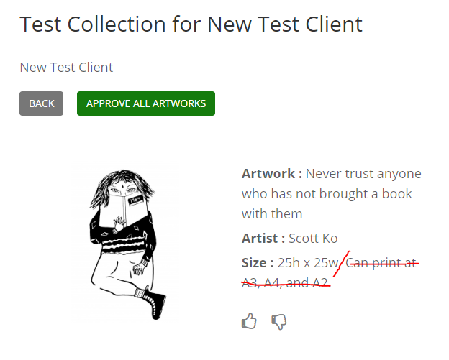

1. BUG: The Blueprint function does not seem to be working, even though a Blueprint has been uploaded Done
   1. Does not seem to be working still. *Issue fixed if there is blue print then we can download the blueprint and if there is no bluprint then its not clickable*
2. With the description field: Can you please put that to the top. Also - not sure why there’s the 3 dots at the end. *Issue fixed please check and confirm*

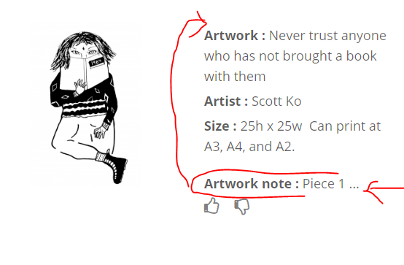

**4.2) Client approves collection**

1. ALL APPROVED

**4.3) Admin receives notifications about Client feedback and reviews collection**

1. Whilst the notification is received in the dashboard about the client approving a new collection, clicking on the Bell takes the Admin to a page that has no collections on it
   1. This bug still exists. I just get taken to a Collections page with nothing on it. *Bug fixed please check and confirm*

**5) Admin manages pick up / display of artwork**

At this point, the Admin now liaises with the Artist to manage pick up of artwork. This is the section where things like ‘Managed by ColourSpace’ and ‘Return Dates’ come into focus.

**5.1) Admin liaises with Artist to arrange collection of artwork**

Admin > Artists > Artworks > Edit Individual Artwork

1. LOW PRIORITY. NOT TESTED. In the DAM (section 5.1.2 and 5.1.3) we talk about introducing functionality that allows us to notify artists through the platform that their artwork is ready for collection. This functionality does not appear to be ready, but let’s WAIT on this functionality for now as we can do it manually. This is considered low priority and we can address later.
2. The double return arrow should be red, and should only display when Today’s date = Date Collected + 365 OR if the artist has changed their artwork to ‘Sold by artist’ Done
   1. Please view this video to see bug.
3. BUG: Royalties do not seem to be working at all.
   1. Still does not seem to be working.

**5.2) Admin arranges for the display of the artwork**

1. UNTESTED DUE TO COLLECTIONS BUG: So the idea is like: “This is your artwork you shared with us. Here is a photo of your artwork on display somewhere.” This functionality is already there. Please log in as admin → Go to Collections → Click on the “Collection Artworks” icon against the collection that is “on display” → Click on the “edit icon” of the required artwork and upload the artwork using the file upload control. E.g. <http://lyonsdemoz.net/cs/admin/collection/collectionartwork/2> just click on the edit icon of the artworks. Tried uploading an image via Collections and instructions. Did not appear to work for me. Also, it feels like the Artworks managed by ColourSpace section is not updating correctly either.

**5.3) Artist review the status of their Artworks**

Artist Login > Artworks shared by ColourSpace

1. For all artworks that ‘On display at client site’ or ‘In temporary storage’, Artists have the ability to tick a box that says that they have sold their artwork. This will notify ADMIN that the artwork needs to be returned to the artist. If the artwork is ‘On display at client site’, then the Artist will be notified that the artwork will be returned at the end of the most recent rotation. If the artwork is ‘In temporary storage’, the Artist will be notified that ColourSpace Team has been informed, and the team will arrange a time for return of artwork.

Artist Login > Your Royalties

Approved pending access to the actual Royalties room.

**For later testing by Scott:**

On Display count: This basically tells the number of times an artwork has been put "on display".

If an artwork is a part of a collection and if that collection goes "on display" then the count of all the artworks within that collection will be increased by 1.